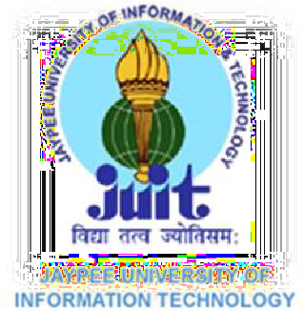LEARNING RESOURCE CENTER

PASTE HERE A RECENT PASSPORT SIZE PHOTOGRAPH
http://www.juit.ac.in/lrc/home.php
Library Membership Form
Please Tick Your Category

B. TECH
M. TECH
M. Sc.
PhD
JRF/ RESEARCH ASSOCIATE

I hereby apply for the membership and permission to borrow books and other Information materials from the Learning Resource Center.

Name: __ _ _ _ _Father Name: ____

Enroll. No. /Roll No.____ Gender:
Female
Male

Department/Branch: (Please Tick)
BI
CIVIL
BT
CSE
IT
ECE
MATHEMATICS
HSS
PHYSICS
CHEMISTRY

Hosteller Non-Hosteller

Permanent Address _ _ _ _ ___ _ _
__ _ _ _ _ _ _ _ District__________________________________State______________________________________________PIN_________________ E-Mail* (Use capital letters only)
Personal Mobile No.*

The information furnished above are true to the best of my knowledge and I agree to abide by the library rules and regulations.
Date: __________/____________/____________________

(Signature of the Applicant) (Signature of the HOD)
Librarian
Circulation In-Charge
For LRC Use Only
Membership No: Membership Type Date: / /

